**E-commerce Website where you can purchase**

**Skincare, Makeup & Haircare products**

**Stage 1: Project Planning -**

I have a Business page on FACEBOOK, so my plan is to create a website of my business page where my customer can buy products as well.

I like to add 3 categories into my Shop Page. These are –

1. Skincare 2. Makeup & 3. Haircare.

**Stage 2: Gathering Requirements & Analysis –**

I created my website on WordPress – which is an open-source web content management system (CMS). I created my WordPress website on localhost. For localhost I used – XAMPP.

**Stage 3: Design –**

I used WOOSTIFY theme and ELEMENTOR as a page builder.

ELEMENTOR – for extra features like Cool Animations, Mobile-friendly Responsive Designs. Responsive Editing, widgets & theme builder.

I used WooCommerce plugin – to convert a normal website into a professional E-commerce website. With woo commerce we can easily access & control our website.

Other plugins – TI WISHLIST, WPFORM, DEPICTER (CUSTOM SLIDER).

**Stage 4: Implementation –**

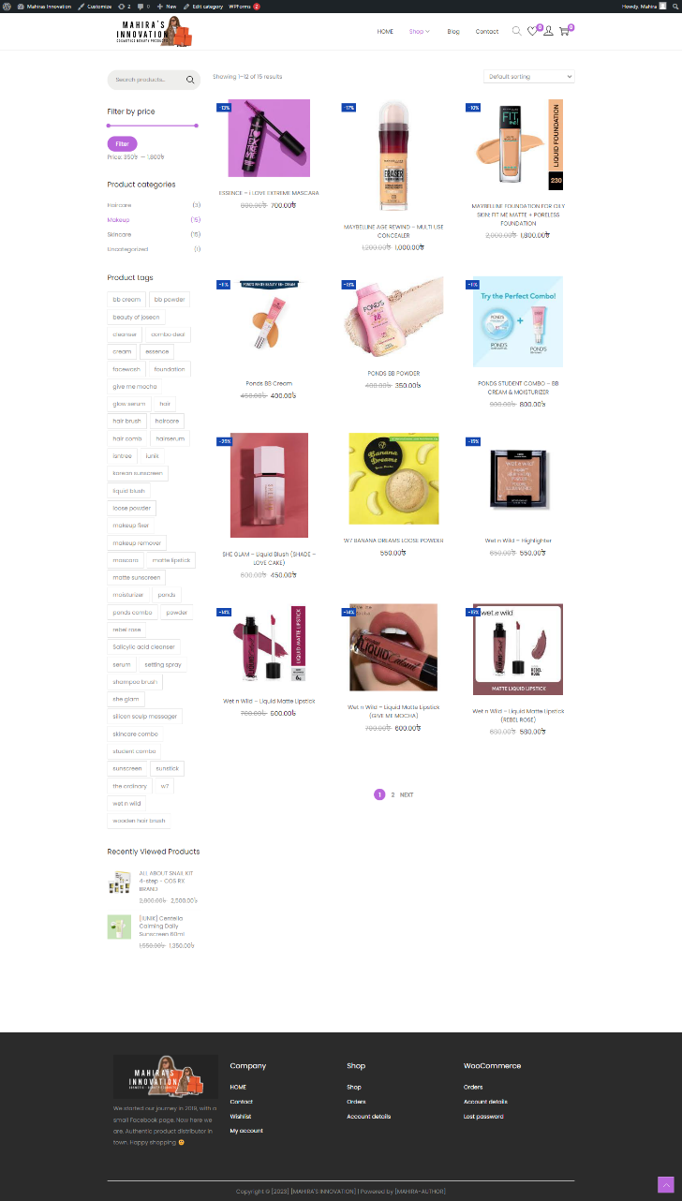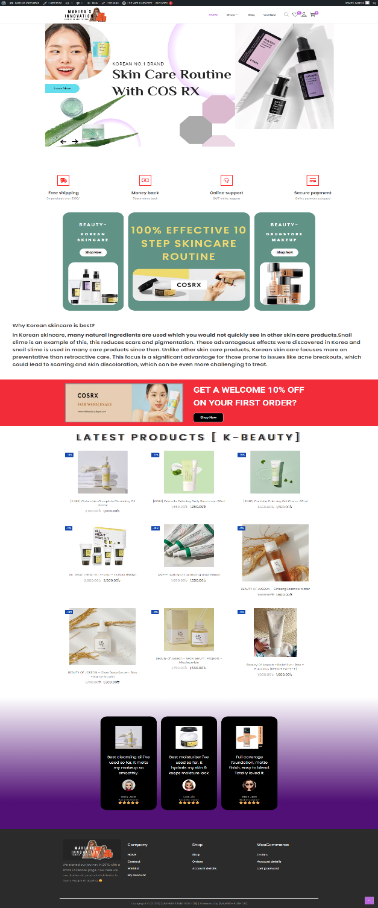For **Homepage** there’s navbar/menu bar, my page logo (linked) and I made customized Depicter Slider with product categories.

Also, there are more sections on Homepage – FAQ’s, Skincare & Makeup preview, Discount Banner on first purchase, Testimonial & lastly Footer.

On the Menu, I added 4 icons & each one has different purpose.

1st. Search Icon - If you click on search icon, a search pop-up will appear.

Users can search their desired product by typing the product name on the search bar. Within few seconds related product will appear.

2nd. Wishlist Icon – If any user/customer wants to buy a product later but also wants to add it somewhere so that they don’t forget the product, they can use this Wishlist Feature.

All they have to do is go to shop page, select the product and tap on Wishlist icon, within few seconds product will be added to the Wishlist.

Later they can visit Wishlist & purchase their desired product by clicking on ‘Add to Cart’ button. They can also delete product from Wishlist.

3rd. Dashboard/Account – User can go to dashboard and see their ordered product, shipping time & also track the parcel as well.

If a user don’t have any account they can create their profile here.

4th. Shopping Cart – User can add their desired product into ‘Cart’ by clicking on the ‘Add to Cart’ feature. It will automatically create a list for the user/customer who wants to buy more than one product. Also, customer can delete any product from cart & Checkout from Shopping Cart as well by clicking on ‘Checkout’ button.

For **Shop Page** I added 3 categories as Drop-Down Menu:

1st one Skincare category, 2nd one is Makeup category and the last one is Haircare category products. On every product – Product Image, Regular Price, Sale price, Description, About the item, Usage are displayed which are User-friendly.

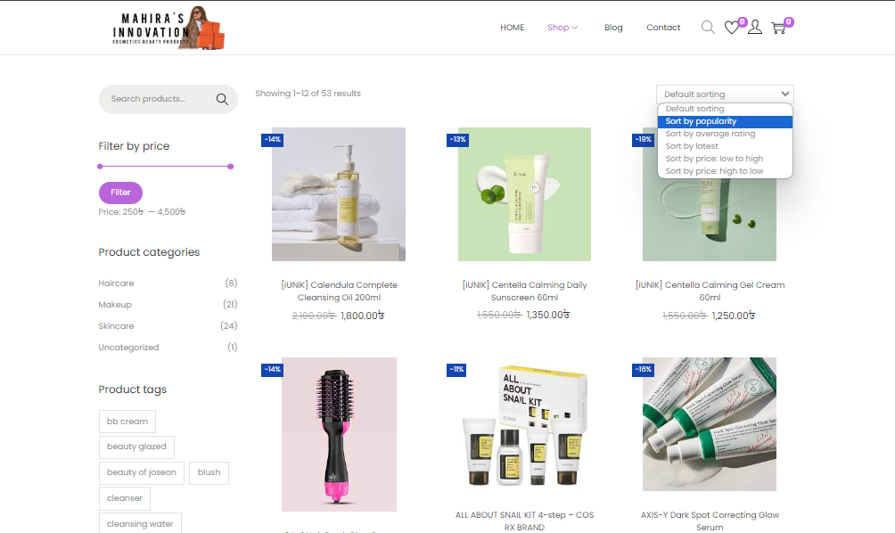

Other Features –

You can filter the price from Side Bar Menu, Sort product by price (low to high/high to low) or by popularity and so on.

From the Side Bar you can also see the product categories and recently viewed products on the website. Lastly you can see the product tags.

With ‘Tags’ you can easily find any product on the website.

**Blog Page**: In here I added Blogs about Brands – which are available on my website. Customer can read the Blog if they have any queries, also there are product information, video, how to use are included.

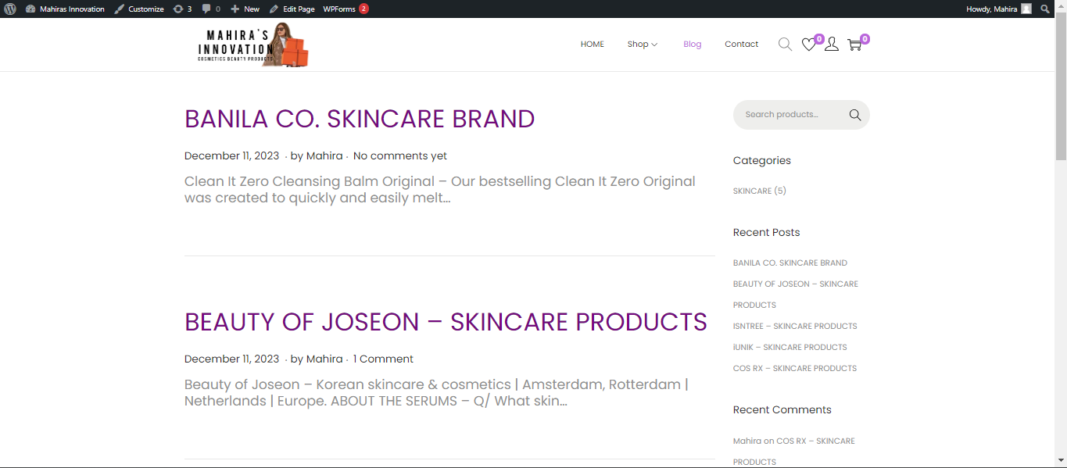

I created a list where user can see the Brand names.

If they ‘click’ on the Brand name, it will lead them to the detail blog.

On the detailed blog page, there is a feature where customer can also leave a comment if they have any queries or questions about any specific product or about the brand. There’s a Side Bar as well, where they can see the Blog Categories, Recently posted Blogs & recent comments.

**Contact Page:** On the contact page I created a Banner then I added

WP FORM – for customers. Like – if they face any problem or want to know something more, they can send us a message though that form,

and that’s how it looks -

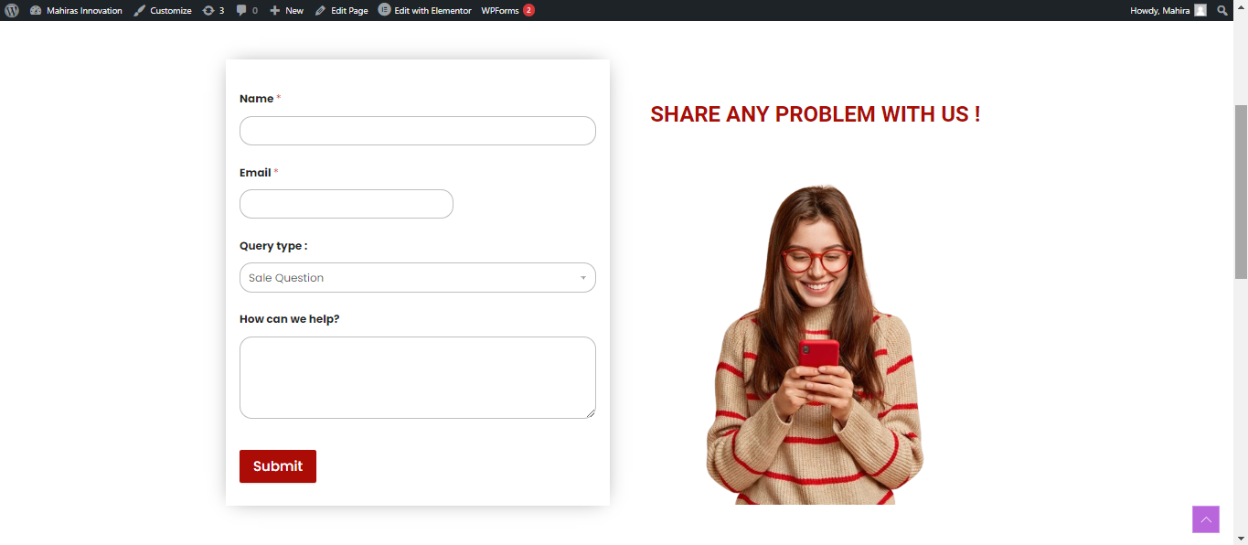

Customers have to insert their Name, E-mail, Query Type & Question.

If they click on the submit button, within few seconds it will be submitted to us and a new pop-up will appear like this –

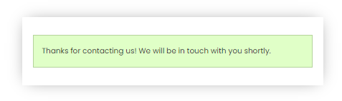

Lastly, there is a Testimonial Section and Footer Section.

**Stage 5: Testing –** Now let’s try ordering from **Mahira’s Innovation.**

1. At first, we have to open our website.
2. Then go to shop page & add few items on “**Shopping Cart**”.
3. Then click on “**View Cart**” button – which will lead you to a **Full View of Shopping Cart Page** or click on “**Checkout**” button, it will lead you to “**Checkout** **Page”.**
4. On the “**Checkout Page**” we can see all the products that we added to cart for purchase & subtotal cost of the products, also the shipping cost (in Chittagong its 80/- taka, Outside Chittagong its 130/- taka. We can see the total payment, as well as payment options which is **Cash on Delivery** - available now.
5. Customers have to Enter their **Name**, **Phone Number**, **Shipping Address** into the “**Contact Information”** as well.
6. There’s a “**Coupon Feature**” available. If anyone wants to activate the Coupon, the have click on “**Add Coupon**” and write “**Shop50**”. And that’s how the coupon code will automatically activate and give the customer flat 50/- taka discount on total payment.
7. Then click on “**Place Order**” and that’s it.
8. Within few seconds your order reciept will appear.

And that’s how you can purchase your product from my website.

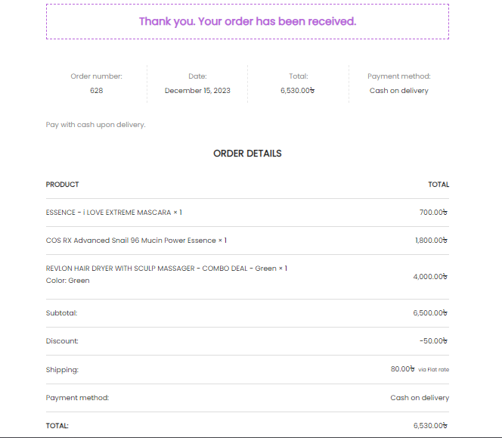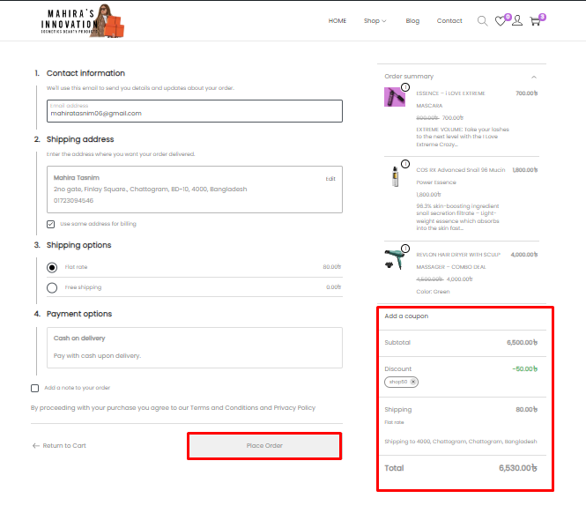 After clicking “**Place Order**” this reciept will appear.